**DC motor**

A [DC motor is an electric motor](https://www.elprocus.com/interfacing-dc-motor-with-8051-microcontroller/) that runs on direct current power. In an electric motor, the operation is dependent upon simple electromagnetism. A current-carrying conductor generates a magnetic field, when this is then placed in an external magnetic field, it will encounter a force proportional to the current in the conductor and to the strength of the external magnetic field. It is a device that converts electrical energy to mechanical energy. It works on the fact that a current-carrying conductor placed in a magnetic field experiences a force that causes it to rotate with respect to its original position. Practical DC Motor consists of field windings to provide the magnetic flux and armature which acts as the conductor.

#### https://www.botnroll.com/2392-medium_default/micro-dc-gear-motor-1-48-dual-axis.jpg Geared DC Motors

Geared motors tend to reduce the speed of the motor but with a corresponding increase in torque. This property comes in handy, as DC motors can rotate at speeds much too fast for an electronic device to makes use of. Geared motors commonly consist of a DC brush motor and a gearbox attached to the shaft. Motors are distinguished as geared by two connected units. It has many applications due to its cost of designing, reduces the complexity, and constructing applications such as industrial equipment, actuators, medical tools, and robotics.

* No good robot can ever be built without gears. All things considered, a good understanding of how gears affect parameters such as torque and velocity is very important.
* Gears work on the principle of mechanical advantage. This implies that by using distinctive gear diameters, we can exchange between rotational velocity and torque. Robots do not have a desirable speed to torque ratio.
* In robotics, torque is better than speed. With gears, it is possible to exchange the high velocity with better torque. The increase in torque is inversely proportional to the reduction in speed.

**Construction**

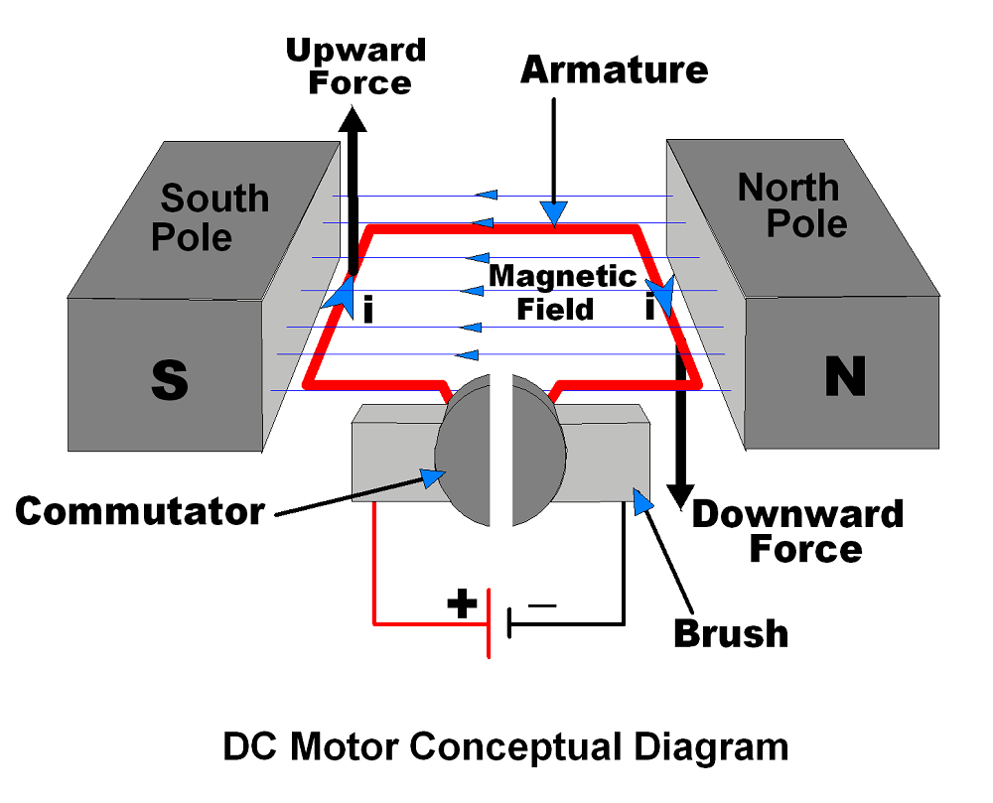

It has mainly two major parts as,

1. **Stator** – Static part of the motor.
2. **Rotor** – Rotating part of the motor.

* The South and North poles of permanent magnet or Electromagnet are the stator part of the DC motor and armature connected with commutator is rotating part of the DC motor.
* South and North poles are used to create a magnetic field as shown in figure.
* The Armature is a conducting material which is placed in between magnetic field produced by North & South pole.
* The current (i) shown in figure is flowing through Armature.
* Brushes are used to attach DC supply to the Armature via commutator.
* Commutators have segments which are attached with each end of conducting Armature. Hence, commutator also rotates with Armature. Brushes are stator part which always keep in contact with commutator.

Principle of working

As shown in above figure left hand side of armature lifting upward and right hand side of armature going downward. This is because of force, which depends upon direction of magnetic field and direction of current flowing through armature. [Fleming’s Left Hand Rule](https://en.wikipedia.org/wiki/Fleming%27s_left-hand_rule_for_motors) is used to determine direction of force (upward/downward).

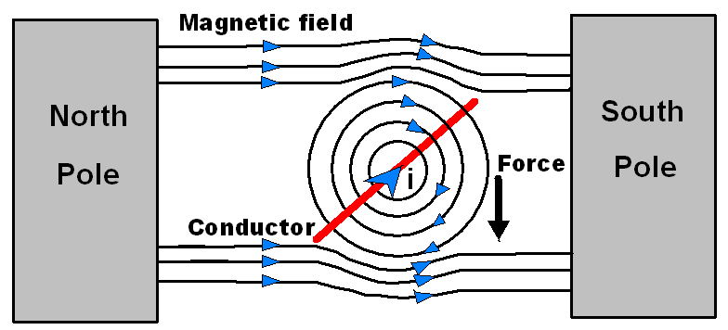

**Clockwise direction**.

Condition: Switch 1and Switch 4 are closed

In this condition Motor will start rotating in **Clockwise direction**.

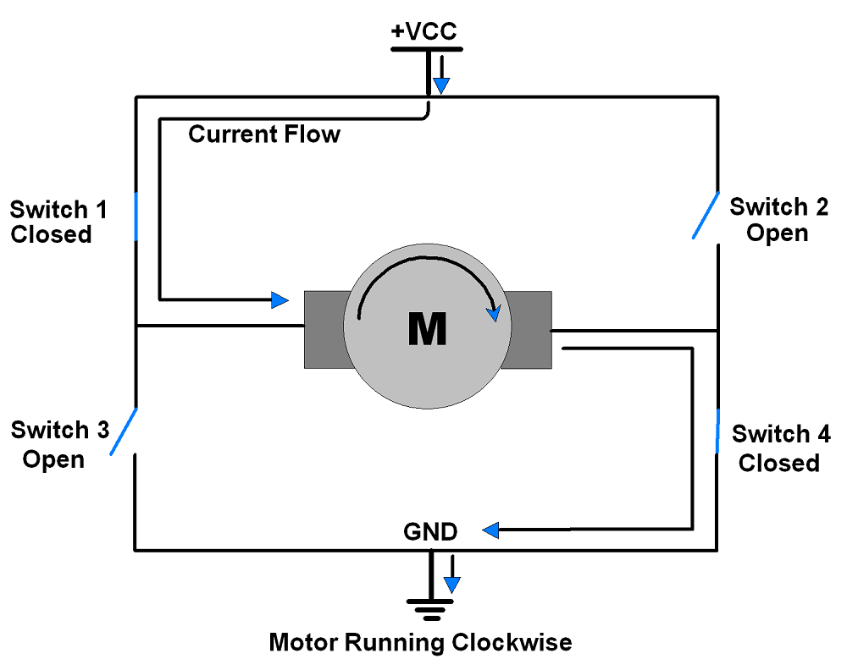

**Anticlockwise direction**.

Condition: Switch 3and Switch 2 are closed.

In this condition Motor will start rotating in **Anticlockwise direction**.

